

***C# BASICS***

**Training Assignments**

| **Document Code** | **25e-BM/HR/HDCV/FSOFT** |
| --- | --- |
| **Version** | **1.1** |
| **Effective Date** | **20/11/2012** |

**Hanoi, 06/2019**

**RECORD OF CHANGES**

| **No** | **Effective Date** | **Change Description** | **Reason** | **Reviewer** | **Approver** |
| --- | --- | --- | --- | --- | --- |
|  | 01/Oct/2018 | Create new | Draft |  |  |
|  | 01/Jun/2019 | Update template | Fsoft template | DieuNT1 |  |
|  |  |  |  |  |  |
|  |  |  |  |  |  |
|  |  |  |  |  |  |
|  |  |  |  |  |  |
|  |  |  |  |  |  |
|  |  |  |  |  |  |
|  |  |  |  |  |  |
|  |  |  |  |  |  |

**Contents**

Day 6: Assignment 18: Manage contacts 4

Objectives: 4

Business needs: 4

Prerequisites: 4

Requirement: 4

Screen requirement: 5

Function requirement: 6

Instructions for students: 6

Estimated time: 30 mins 6

|  | **CODE: Net.M.A018**  **TYPE: MEDIUM**  **LOC: 190**  **DURATION: 30 MINUTES** |
| --- | --- |

# Day 6: Assignment 18: Manage contacts

**Objectives:**

* Understand and practice with Collection in C#.
* Understand and practice ADO.NET.
* Understand and practice List and exception.
* Practice code in Visual Studio.
* Follow coding convention.

**Business needs:**

* TBD

**Prerequisites:**

* Working environment: Visual Studio 2013 or higher.Practice code in Visual Studio
* Each exercise is one project inside 1 solution.

**Requirement:**

Write a program to manage directory management as follows:

Show menu:

Contact

1. Add a contact.

2. Display all contacts

3. Delete a contact.

4. Exit

User selection:

1. If the user chooses 1, let them add an address. Each address includes ID (int), fullname (String), group (String), address (String), phone (String), lastName (String), firstname (String), where ID is an automatic increase (i.e. The new contact has an ID equal to the last contact ID + 1), the first contact has ID: 1, name is taken from firstName and lastName separated by space marks.

2. If the user chooses 2, the program displays the data list as follows:

ID Name First Name Last Name Group Address Phone

1 Iker Casillas Iker Casillas Star Spain 1234567890

2 John Terry John Terry Star England 1234567890

3 Raúl González Raúl González Star Spain 1234567890

3. If the user chooses 3, the program requires entering the contact ID to be deleted, if no ID exists, displays a message: "No contact found".

4. If the user selects 4, exit the program.

Note the phone can only import the following formats:

* 1234567890
* 123-456-7890
* 123-456-7890 x1234
* 123-456-7890 ext1234
* (123)-456-7890
* 123.456.7890
* 123 456 7890

**Screen requirement:**

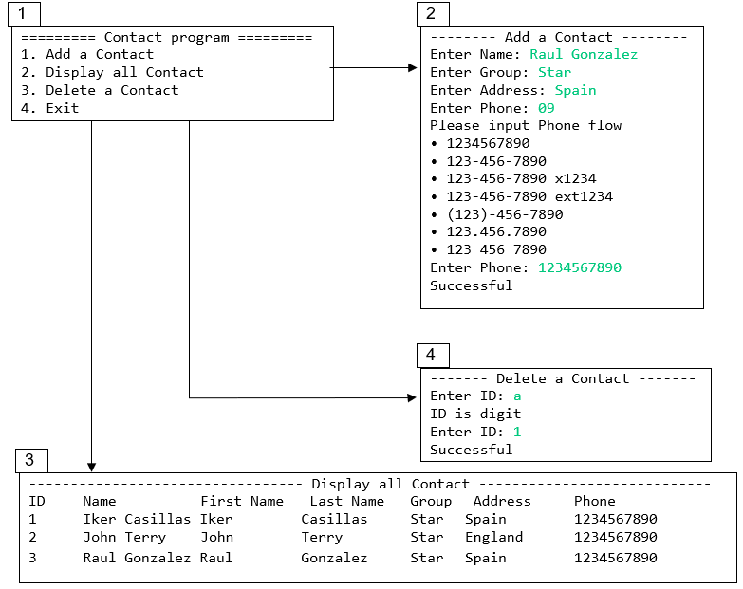

**Function requirement:**

**Prerequisites:**

* The user runs the application, the program displays a menu asking the user to enter the option.
* Next, the program makes a selection and returns to the menu.

**Function 1: Add new contact**

* Function name in code: public boolean addContact(List<Contact> list, Contact contact)
  + Input:
    - List: list contacts
    - Contact: contact info
  + Return value: add contact status.

**Function 2: Display list contact**

* Function name in code: public void displayAll(List< Contact > list).
  + Input:
    - List: list contacts
  + Return value: add contact status

**Function 3: Remove contact**

* Function name in code: public boolean deleteContact(List<Contact> list, Contact contact)
  + Input:
    - List: list contacts
    - Contact: contact wants to delete.
  + Return value: delete contact status

**Instructions for students:**

Design 1 database consists of 1 table Contact (Id, FirstName, lastName, Group, Address, Phone). Id is the primary key and cannot be identified as an identity.

Connect to the database and manipulate this database

**Estimated time:** 30 mins